week one:

December 6-12
THE LIGHT OF HOPE
The world has experienced much darkness over the past months. Just as the days begin to get longer, so we have hope for the future in the Light of Christ. As Isaiah prophesied, our hope in Christ is for all nations and for all time – even a socially-distanced pandemic Christmas.

“Arise, shine, for your light has come,
and the glory of the Lord rises upon you.”
~ Isaiah 60:1, NIRV

- Give thanks for recent opportunities for Christian Horizons to develop affordable housing initiatives in Grimsby and Thunder Bay Ontario. May God guide and direct the work that we do together. Help it to bless the families who experience disability and their wider communities.
- Pray for the people of Central America as they recover from two hurricanes that hit in November. Pray also for Christian Horizons Global partners as they reach out to support communities battered by the hurricanes.
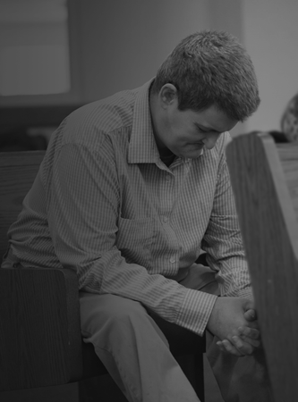
Feedback or requests?
2020
PRAYER GUIDE

ORGANIZATIONAL & SPIRITUAL LIFE

Mark Wallace, MTS
Keith Dow, PhD
Chantal Huinink, MDiv, RSW

(519) 783-6810
ministry@christian-horizons.org

Nadha is a 2019-2020 graduate of the Humber College culinary program in partnership with Christian Horizons. Congratulations, Nadha!
This month’s prayer guide highlights the work of Christian Horizons in the GTA, through affordable housing, and around the world through Christian Horizons Global.

December

“A messenger is calling out in the desert, ‘Prepare the way for the LORD. Make a straight road through it for our God.’”
~ Isaiah 40:3, NIRV

week two:

December 13-19
“An angel of the Lord appeared to [Joseph] in a dream. The angel said, ‘Joseph, son of David, don’t be afraid to take Mary home as your wife. The baby inside her is from the Holy Spirit.’” ~ Matthew 1:20, NIRV
THOUGHT: An angel alerts Joseph to the fact that his baby, Jesus, would be both extraordinary (born of the Holy Spirit) and ordinary. Rather than growing up in a palace, Jesus the Messiah would grow up in a home. There is truly something ordinary and extraordinary about the blessing of a home.

- Praise God for new supportive housing initiatives, made possible in part through developing relationships within the business world. May God continue to strengthen and bless these partnerships.
- Pray for peace and Stability in Ethiopia.
- Give thanks for God’s provision: meeting our needs and leading us to great partners and cross-organizational and sector collaborations.
- Pray for Christian Horizons’ partnership with Humber College as we work together to create new opportunities for people with disabilities to earn a college education. Pray for wisdom and safety as we work to launch a January 2021 Culinary Certification program.
week three:

December 20-26
“So the Word became human and made his home among us. The Word became flesh and blood, and moved into the neighborhood.”
~ John 1:14, NLT
THOUGHT: In this season, we may be faced with dark times due to fewer hours of sunlight, pandemic related restrictions, or other stresses. This verse reminds us that such conditions are impermanent. God is still with us; still working in and through us. He continues to bless people and glorify himself.
THOUGHT: Christmas is an opportunity to celebrate how Jesus our Lord and our Saviour humbled himself to be part of our community and truly relate to what we feel. Later he would make it possible for us to be part of his community eternally, by dying on the cross for us.

- Praise God for the relationships that led Christian Horizons to begin offering innovative supports and services to people in areas such as Grimsby, Ontario. Pray for strength of all those involved to meet the tight timelines and for God to lay the need of this project on the hearts of those who have the resources to contribute financially.
- Give thanks for the Community Participation Supports Team in Toronto at “The Village” who are working hard to provide virtual programming to the community amidst the coronavirus pandemic.
- Pray for families that are experiencing isolation where pandemic related restrictions are in place.
week four:

Dec 27-Jan 2
“Darkness covers the earth. Thick darkness spreads over the nations.
But I will rise and shine on you. My glory will appear over you.”
~ Isaiah 60:2, NIRV

- May God generate enthusiasm and financial and spiritual support for Christian Horizons’ newest affordable, supportive housing initiative within the community of Grimsby Ontario!
- Pray for wisdom and safety within the central-Ontario region of Christian Horizons as they re-engage in revised processes for how people access supports and services.
- We give thanks for the Canada Summer Jobs program and its flexibility this past year which provided such great benefit to our services and teams.
- Pray health and safety in all countries where Christian Horizons supports people. Pray for complete recovery of those who suffer with coronavirus, a reduction of its spread, and timely distribution of an effective vaccine.

